2021 - 2022 School Supply List
Kindergarten
 | Item | Quantity
 | 1” Durable 3-Ring Binder with Clear Front Pocket | 1
 | 24 Count Crayola Crayons | 4 sets
 | Glue Sticks | 12
 | Kleenex | 2
 | Crayola Washable Markers - Classic Colors (NO BOLD COLORS PLEASE) | 2 pkgs.
 | THIN Plastic Rest Mat (45”x19”x5/8”) – NO ROLL MATS/NO CLOTH MATS | 1
 | Large Towel or thin blanket | 1
 | Pocket Folder (Plastic or Vinyl) | 2
 | PRANG Watercolors (sold at Mardel or Hobby Lobby) | 1
 | School Supply Box | 1
 | Scissors - Blunt | 1
 | Spiral Notebook - Wide Rule | 1
 | Twistable Colored PENCILS – NOT CRAYONS | 1 pkg.
 | 24 Count Ticonderoga Pencils | 1 pkg.
 | Baby Wipes | 1
 | Clorox Disinfecting Wipes | 2
 | Individually Wrapped Snacks | 1 bulk box
 | Paper Towels | 2 rolls
 | Large Backpack - NO ROLLING BACKPACKS | 1
 | Lunchbox or Lunch Money
 | The supplies below will be charged to your FACTS account
 | $20 education support fee charged through FACTS
 | $5 Fall Festival
 | $10 Studio Fee charged through FACTS ($5 a semester to help cover competition fees and Re-stock the art room throughout the year)
 | Art Supplies
 | Box/package of black sharpie markers (Original Felt tip) | 1
 | Box/package of black sharpie markers (Ultra Fine Tip) | 1
 | Chinet Cut Crystal Clear Plastic Dessert Plate 7”, 30 Count | 1
 | Bottle of Elmers glue | 1
 | Roll of paper towels | 1
 | tub of disinfecting wipes (Clorex, Lysol or Namebrand) | 1
 | 8ct pkg of Washable Markers | 1
 | Roll of Masking Tape | 1
 | Roll Aluminum Foil | 1
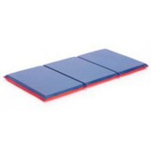
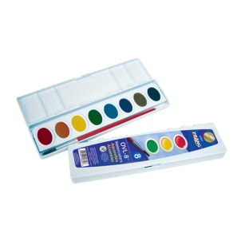
NOTE: Please write the student’s name or initials on EACH individual marker, crayon and Twistable. No need to put child’s name on glue sticks, Kleenex, or wipes
45” x 19” x 5/8”
14" x 8" x 4 7/8"
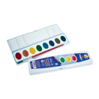
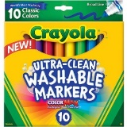
45” x 19” x 5/8”

