2021 – 2022 School Supply List
Pre-Kindergarten
 | Item | Quantity
 | White 1” Binder | 1
 | 24 Count Crayola Crayons | 3
 | Elmer’s Glue Sticks | 12
 | 10 Count Crayola Classic Washable Markers (NO BOLD COLORS) | 2
 | THIN Plastic Rest Mat (45”x19”x5/8”) – NO ROLL MATS/NO CLOTH MATS | 1
 | Towel for Rest Time | 1
 | Pocket Folder (no brads) | 2
 | 8 Count Crayola Washable Water Colors | 1
 | School Supply Box | 1
 | Scissors - Blunt | 1
 | Individually Packaged Non-Perishable Snacks  (ie: Goldfish, Vanilla Wafers, Teddy Grahams) | 1 Bulk Box
 | Kleenex | 3
 | Sandwich Size Ziplock Baggies | 1 box
 | Clorox Disinfecting Wipes | 1
 | Baby Wipes | 1
 | Paper Towels | 2 Rolls
 | Backpack - NO ROLLING BACKPACKS | 1
 | Lunchbox
 | The supplies below will be charged to your FACTS account
 | $20 education support fee
 | $10 Studio Fee ($5 a semester to help cover competition fees and Re-stock the art room throughout the year)
 | Art Supplies
 | Box/package of black sharpie markers (Original Felt tip) | 1
 | Box/package of black sharpie markers (Ultra Fine Tip) | 1
 | Chinet Cut Crystal Clear Plastic Dessert Plate 7”, 30 Count | 1
 | Bottle of Elmers glue | 1
 | Roll of paper towels | 1
 | tub of disinfecting wipes (Clorex, Lysol or Namebrand) | 1
 | 8ct pkg of Washable Markers | 1
 | Roll of Masking Tape | 1
 | Roll Aluminum Foil | 1
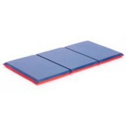
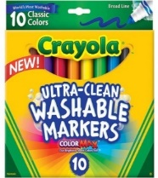
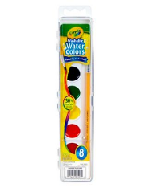
45” x 19” x 5/8”

